UNIVERSITY OF RWANDA
COLLEGE OF SCIENCE AND TECHNOLOGY
School of ICT
Department of Computer and Software Engineering
WEB DESIGN TECHNICAL REPORT

UNIQUE HOTEL WEBSITE
An Interactive Luxury Stay and Membership Platform
Module: Web Design
Prepared by:IZERE ABIJURU Cyprien
Registration Number: 225030699
Program: Computer Engineering / Information Technology
Year of Study: Year 1
Academic Year: 2025–2026

ACKNOWLEDGEMENT
Firstly, I sincerely appreciate the University of Rwanda, College of Science and Technology, and particularly to the lecturers in the Department of Computer Engineering, for providing knowledge that guided me throughout this project
I also extend my gratitude to my classmates and friends for their suggestions and ideas for their continuous support, patience, and motivation.
ABSTRACT
This report presents the design and development of a customer guide webpage for Unique hotel. The site aims to provide guests with easy access to essentials such as room services, dining options, and local attractions user-friendly navigation and responsive layout. The final product successfully delivers a clear, visually appealing digital guide that enhance the guest experience.
Keywords: Web Design, Hospitality Architecture, Membership Portal, Responsive Layout, HTML, CSS, JavaScript, UNIQUE HOTEL.

TABLE OF CONTENTS
Acknowledgement ...................................................................................................2
Abstract.................................................................................................................... 2
List of figures.............................................................................................................. 5
List of tables................................................................................................................ 5
List of abbreviation............................................................................................. 6
CHAPTER ONE: INTRODUCTION .................................................................................7
1.1 Historical Backgroun............................................................................................... 7
1.2 Problem Statemen....................................................................................................7
1.3 Objectives..................................................................................................................7
1.4 Expected Outcomes................................................................................................. 8
1.5 Project Rationale........................................................................................................8
1.6 Scope of the Project...................................................................................................8
1.7 Limitations..................................................................................................................8
CHAPTER TWO: SYSTEM ANALYSIS AND DESIGN ................................................ 9
2.1 System Analysis.........................................................................................................9
2.2 System Desig........................................................................................................10
CHAPTER THREE: SYSTEM IMPLEMENTATION.................................................. 14
3.1 Introduction .............................................................................................................14
3.2 Development Environment ......................................................................................14
3.3 Programming Languages Used ...............................................................................14
3.4 Home & Hero Page Implementation ........................................................................14
3.5 About Section Implementation................................................................................ 14
3.6 Services Module Implementation ............................................................................15
3.7 Locations Mapping Module ..................................................................................... 15
3.8 Dining Menu & Table Booking Module .................................................................. 16
3.9 Membership Portal & Client Authentication Interface .......................................... 17
3.10 Responsive Framework .........................................................................................18
3.11 Summary ...............................................................................................................18
CHAPTER FOUR: CONCLUSION AND RECOMMENDATIONS ........................... 19
4.1 Introduction .............................................................................................................19
4.2 Conclusion ...............................................................................................................19
4.3 Recommendations ...................................................................................................19
REFERENCES........................................................................................................... 20
APPENDICES.............................................................................................................. 20

LIST OF FIGURES
Figure 2.1: System Architecture of UNIQUE HOTEL
Figure 2.2: Use Case Diagram for Guests, Members, and Admins
Figure 2.3: Entity Relationship Diagram (ERD) for Future Database Integration
Figure 2.4: Website Navigation Tree Hierarchy
Figure 2.5: User Flow Chart for Booking and Membership Registration
Figure 3.1: Main Landing Interface and Banner Layout
Figure 3.2: Specialized Services Grid Interface
Figure 3.3: Location Directory Section
Figure 3.4: Interactive Dining Menu & Booking Triggers
Figure 3.5: Membership Sign-Up and Login Portal Form
LIST OF TABLES
Table 2.1: Functional Requirements Outline
Table 2.2: Non-Functional Layout Requirements
Table 2.3: User Role Descriptions
Table 2.4: Proposed Backend Database Schema
Table 2.5: Software Component Requirements
Table 3.1: Applied Engineering Tools & Environments
LIST OF ABBREVIATIONS
Abbreviation | Meaning
HTML | Hypertext Markup Language
CSS | Cascading Style Sheets
JS | JavaScript
UI | User Interface
UX | User Experience
ERD | Entity Relationship Diagram
HTTPS | Hypertext Transfer Protocol Secure
RDB | Rwanda Development Board
ICT | Information and Communication Technology

CHAPTER ONE: INTRODUCTION
1.1 Historical Background
The tourism and hospitality industry serves as an essential pillar of public economic development and foreign direct investment in Rwanda. Traditionally, local lodging details and booking systems were localized, reliant on face-to-face check-ins, phone reservations, and static print pamphlets. While functional historically, these setups present clear limitations: print details cannot easily update prices, remote international travelers encounter friction trying to assess locations, and manual verification creates bottlenecks.
With national digital growth championed by the Ministry of ICT and Innovation, plus rapid internet expansion across Rwandan cities, consumers expect instantaneous service access. Despite these shifts, minor hospitality setups remain isolated or depend solely on large third-party booking sites that lack personalized direct member interactions. Dynamic local hotel options need dedicated, lightweight storefront layouts. The UNIQUE HOTEL platform was designed to fill this specific space.
1.2 Problem Statement
Many travelers lack an organized, direct online portal to verify room configurations, amenities, and locations for specialized regional hotels in Rwanda. Existing web solutions remain split, heavily technical, or completely static, failing to provide interactive rewards that encourage guest retention. Consequently, customers lack immediate clarity regarding amenities across urban hubs (like Kigali) versus remote destinations (like Musanze or Rubavu). Unique Hotel closes this communication loop by offering a free, universally responsive client-side interface featuring booking triggers and real-time membership discount promotions.
1.3 Objectives
1.3.1 General Objective
To design and deploy an interactive web application framework for Unique Hotel that aggregates services, multiple regional branches, dynamic booking links, and an exclusive customer registration system.
1.3.2 Specific Objectives
- To code an adaptive, modern UI layout utilizing semantic HTML5 and CSS3.
- To organize business capabilities into clean components: Services, Locations, Dining, and Portal Sections.
- To implement a JavaScript module that alerts members of a 5% discount structure.
- To construct structural login and registration forms for clients.
- To push source assets cleanly via Git and host the final application using GitHub Pages.
1.4 Expected Outcomes
- A fully working front-end hotel deployment accessible publicly via any standard device browser.
- Streamlined service exploration covering accommodations, spa options, and event halls.
- An operational registration page that pre-validates user values.
- A structural platform ready for future connection to secure database layers.

1.5 Project Rationale
Rwanda's domestic and international travel tracking is increasingly digital. Building the layout using standard vanilla languages (HTML, CSS, JavaScript) creates highly optimized page performance, fast paint-times over restricted mobile bandwidth links, and zero hosting costs through GitHub Pages. Educationally, the project applies structural fundamentals, interface layout styling, responsive breakpoints, and client-side scripting rules taught in the Web Design module to an actual commercial use-case.
1.6 Scope of the Project
The report encompasses the technical production of a static web architecture featuring a Home header, About overview, 6 Core Services, 5 Geographic Branch lists, Menu tables, Booking triggers, and Account registration forms. Advanced database tracking and payment gateways are marked out-of-scope for future phases.
1.7 Limitations
- No active backend database engine is attached; user field variables are not persisted permanently between server refreshes.
- Menu pricing or room options must be modified manually in the source HTML markup by the developer.
- The booking triggers simulate structural flows rather than routing to live financial APIs.

CHAPTER TWO: SYSTEM ANALYSIS AND DESIGN
2.1 System Analysis
2.1.1 Analysis of the Existing Situation
Hospitality operations often use rigid, external booking aggregators. These systems charge high commission fees, hide direct brand communication, and lack custom features like an instant 5% member discount on meals. Direct web interfaces are needed to make localized hospitality more competitive.
2.1.2 Proposed System
The proposed Unique Hotel site functions as an independent, single-destination hub. Guests can browse real-time services, locate regional venues, view promotions, and trigger registrations without any platform overhead.
2.1.3 Functional Requirements
- FR1 Account Portals: Users must be able to fill sign-up and login inputs with client-side form validation.
- FR2 Services Layout: System must display a clean breakdown of the 6 core amenities.
- FR3 Location Routing: Guests can review operational branches spanning 5 specific Rwandan districts.
- FR4 Dynamic Discounting: Interface highlights and processes the 5% membership discount incentive automatically across menu assets.
- FR5 Booking Triggers: Users can toggle action buttons for menus and table reservations.
2.1.4 Non-Functional Requirements
- NFR1 Usability: Clean typography and a luxurious color palette accessible to first-time users.
- NFR2 Breakpoint Responsiveness: Mobile-first layout configuration matching smartphones, tablets, and large displays.
- NFR3 Performance: Lightweight elements ensuring load times remain under 2 seconds over standard mobile connections.
2.1.5 User Description
- Visitor: General user who browses amenities, locations, and menus.
- Registered Member: Verified account holder authorized to receive 5% off dining selections.
- System Admin: Internal technician tasked with modifying pricing variables and local text files.
2.2 System Design
2.2.1 System Architecture
The application uses a three-tier static-web architecture model:
- Client Layer: Renders DOM content inside Chrome, Edge, Safari, or Firefox viewports.
- Front-End Layer: Combines HTML5 markup for content layout, CSS3 for grid flex alignments, and JavaScript for structural interaction workflows.
- Deployment Layer: Uses Git repositories hosted on GitHub servers to feed assets down to user targets via GitHub Pages over HTTPS.
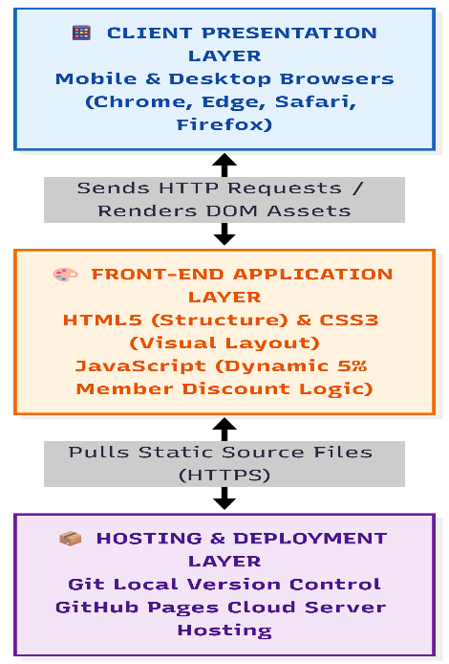

2.2.2 Use Case Diagram
- Visitor/Guest: Toggles Browse Locations, View Menu, Trigger Bookings, and Register Account.
- Member: Accesses Login, and logs in to access the Claim 5% Discount structural rule.
- Admin: Edits Manage Text Content and updates local text parameters.
2.2.3 Entity Relationship Diagram (Proposed for Future Database Integration)
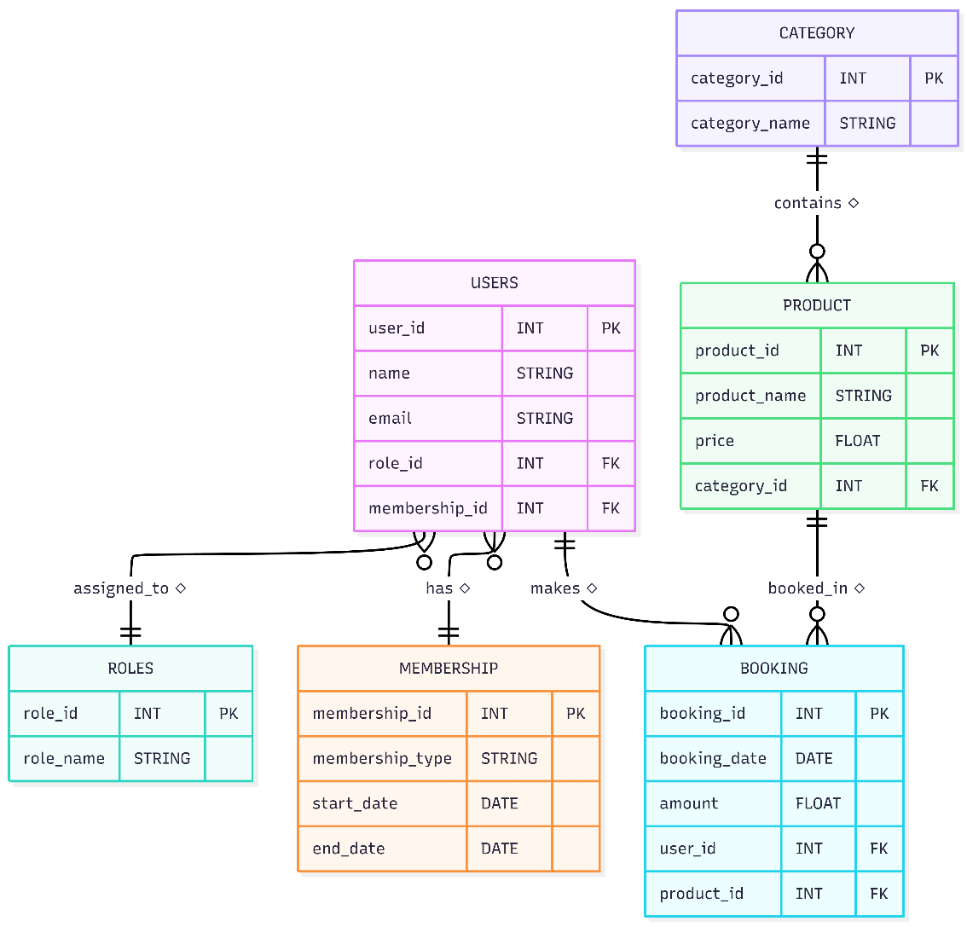

CHAPTER THREE: SYSTEM IMPLEMENTATION
3.1 Introduction
This chapter Details the practical build-out of the Unique Hotel web project. It covers tool choices, stylesheet parameters, layout elements, and functional logic, alongside structural breakdowns of each page interface.
3.2 Development Environment
Engineering Tool | Technical Purpose
Visual Studio Code | Text editor used for engineering source markup, styles, and logic files.
HTML5 Engine | Framework for semantic structural elements across all modules.
CSS3 Stylesheets | Set layout parameters, custom flex rows, typography, and responsive media query blocks.
JavaScript (ES6+) | Code interactive components, toggle portal states, and configure user alerts.
Git & GitHub | Source management, command tracking, and public deployment via GitHub Pages.
3.3 Programming Languages Applied
- HTML5: Structures all core blocks including <header>, <nav>, <section id="services">, grids for locations, menu tables, and input forms.
- CSS3: Establishes a premium color palette (such as dark gold, deep slate, and warm creams) representing luxury hospitality, with responsive layout rules to fit varying device sizes.
- JavaScript: Runs client-side functions, form inputs validation, and updates discount conditions.
3.4 Home Page & Hero Layout Implementation
The landing view introduces the premium branding of Unique Hotel Rwanda immediately upon entry.
- Key Features: Fixed clear header navigation, active main hero tag lines reading "Experience Excellence - Delicious dining and luxury stays await you," and prominent action targets linked directly to booking elements.
3.5 About Section Implementation
This structural element displays the hotel's foundational values and core hospitality commitment. It features an overview layout containing text blocks that introduce the hotel's mission statement: "Unique Hotel Rwanda offers a luxurious and relaxing experience with world-class hospitality, providing exceptional service and modern facilities for local and international guests."
3.6 Services Module Implementation
This functional block displays the core hotel features using a responsive CSS Flexbox layout grid. It highlights six primary services:
- 24/7 Room Service
- Free Wi-Fi
- Swimming Pool
- Conference Rooms
- Airport Pickup & Drop-off
- Spa & Wellness Center
3.7 Locations Mapping Module
The regional presence of Unique Hotel across Rwanda is organized into an accessible card component. To assist guest planning, the site displays five key geographic locations:
- Kigali City
- Musanze
- Rubavu (Gisenyi)
- Muhanga
- Nyagatare
3.8 Dining Menu & Table Booking Module
This module details the hotel's luxury restaurant and dining options.
- Key Components: A structural layout for the View Menu list, paired with an interactive Book a Table reservation button. It features a prominent callout explaining the guest incentive program: "On everything that is on our menu we give 5% discount to our members."
3.9 Membership Portal & Authentication Interface
The account view manages guest registration and access.
- Key Components: Structured form elements containing text fields for Username, Email, and Password values. It uses anchor routes labeled "Join Our Membership" and "Sign Up & Login" to handle user registration flows.

CHAPTER FOUR: CONCLUSION AND RECOMMENDATIONS
4.1 Introduction
This section summarizes the design achievements of the Unique Hotel project, verifies development goals against the initial scope, and suggests future enhancements.
4.2 Conclusion
The development of the Unique Hotel website successfully creates an accessible, responsive web presence tailored for regional tourism and hospitality operations. The application organizes essential business info—such as regional branches, specialized guest amenities, dining menus, and member portals—into a unified user experience.
By building the site with standard HTML, CSS, and JavaScript, the project shows that front-end layouts can effectively support client interactions without requiring complex backend servers. The project meets its primary educational goals, establishing a reliable foundation for future commercial updates.
4.3 Recommendations
- Database Connection: Connect a secure relational database (such as PostgreSQL or MySQL) to save user registration data and booking history.
- Live Booking Logic: Add interactive calendar pickers and check-in date rules to automate room tracking.
- Payment Integration: Integrate local and international payment options like MoMo API, MasterCard, and Visa.
- Localization Support: Add language selection choices for English, Kinyarwanda, and French.

REFERENCES
- GitHub. (2024). GitHub Pages documentation. github.com
- Mozilla Developer Network. (2024). CSS structural layout rules. mozilla.org
- Mozilla Developer Network. (2024). HTML element references. mozilla.org
- World Health Organization / Rwanda Development Board. (2024). Tourism hospitality digital guidelines.
- W3Schools. (2024). HTML, CSS, and JavaScript web development tutorials. w3schools.com

APPENDICES
Appendix A: Project Repository and Live Deployment Details
Project Title: Unique Hotel Rwanda Website
Source Code Repository: https://github.com/izerecyp/Unique-hotel
Live Website URL: https://izerecyp.github.io/Unique-hotel/

Appendix B: Functional User Manual
Step 1: Open the live link https://izerecyp.github.io/Unique-hotel/ inside a modern web browser.
Step 2: Review the hero banner area to understand the primary hospitality options.
Step 3: Scroll to the Services grid to check hotel amenities like the pool, spa, and Wi-Fi.
Step 4: Navigate down to the Location directory to find regional hotel branches.
Step 5: Click the Join Our Membership action link to access the customer registration

